

PUSL3190 Computing Project

Project Initiation Document

Socially Aware Embodied Language Agent

Supervisor: Ms. Dulanjali Wijesekara

Name: Galgana A Gamlath
Plymouth Index Number: 10953516
Degree Program: BSc. (Honours) Computer Science

Table of Contents

Chapter 01 Introduction 3
Chapter 02 Business Case 4
Business Objectives 4
Chapter 03 Project Objectives 5
Project Objectives:- 5
Functional Deliverables 5
Quality Requirements and Performance Measures 6
Chapter 04 Literature Review 7
Chapter 05 Method of Approach 11
Chapter 06 Conceptual Diagram 14
Chapter 07 Initial Project Plan 15
Chapter 08 Risk Analysis 16
References 17

Chapter 01 Introduction

Conversational agents have become a core component of modern human–computer interaction. It transforms how users interact with digital systems across domains such as education, healthcare, and customer service worldwide (Sinan Sonlu, 2024). Advances in artificial intelligence and large language models have significantly improved the fluency and contextual relevance of conversational systems, accelerating their global adoption.

International organizations such as the United Nations have highlighted the importance of AI-driven conversational technologies. These systems support accessibility, digital inclusion, and improved service delivery across diverse populations. (Anon., 2023). Major technology companies such as Google and OpenAI highlight conversational AI as a key technology for future digital experiences. Many countries have introduced national strategies to integrate conversational assistants into public services and education since 2018 (Che-Jui Chang, 2023), (Hailun Lian, 2023).

Most existing conversational systems rely on text-based interaction. This limits their ability to capture emotion, personality, and non-verbal cues. (Andrei Nosov, 2024). Human communication is inherently multimodal. It involves facial expressions, tone of the voice, and prosodic features that convey emotional and social intent. However most current chatbots are unable to interpret these signals in real time. (Kumar Shubham, 2022)As a result, interactions often appear mechanical and detached. This limits user trust, engagement, and long-term effectiveness. In the Sri Lankan context, undergraduate research projects and local technology initiatives have begun experimenting with voice-based and avatar-driven conversational systems. However, most implementations remain limited to simple question-and-answer mechanisms rather than truly empathetic and socially aware interaction models. (Simon Christophe Jolibois, 2025). Furthermore, many existing multimodal or embodied conversational frameworks are computationally intensive.
Others are limited to a single modality. These limitations reduce their suitability for scalable educational and assistive applications (Che-Jui Chang, 2023).

The purpose of the Socially Aware Embodied Language Agent project is to explore how a real time conversational agent can support socially aware interaction. The system incorporates emotional and personality cues while remaining lightweight and efficient. This research investigates a unified approach that integrates multimodal perception, language reasoning, and embodied interaction to address limitations in existing systems. The scope of the project is limited to the design and evaluation of a research-oriented prototype for experimental and educational use. It is not intended for full-scale production deployment. The expected impact is improved user engagement, trust, and interaction quality in conversational systems, particularly in educational environments. Key stakeholders include students, educators, researchers, and developers interested in human-centered artificial intelligence and socially intelligent conversational technologies (Sinan Sonlu, 2024).

Chapter 02 Business Case

Modern businesses are increasingly adopting conversational AI systems to improve operational efficiency and customer engagement. However, many existing conversational agents fail to meet user expectations due to limited emotional awareness and a lack of social intelligence. As a result, users often perceive these systems as impersonal or unempathetic. This leads to frustration, reduced trust, and lower user retention.

These limitations are especially critical in emotionally sensitive domains such as healthcare support, educational platforms, and customer service. In such contexts, emotionally inappropriate or insensitive interactions can negatively affect user satisfaction, communication effectiveness and overall service quality. Therefore, businesses require conversational agents that can understand users’ emotional states, adapt responses dynamically and provide more human-like interaction experiences.

SELA addresses this business need by offering a socially aware embodied conversational agent. The system integrates emotional understanding into real time interactions.
By incorporating multimodal emotion recognition and adaptive embodied responses, SELA enhances empathy, engagement, and effectiveness in communication. This capability presents a strong business opportunity to improve customer satisfaction, strengthen trust in AI-driven services, and differentiate offerings in competitive markets.

Business Objectives

The business objectives of the SELA project are to:-

- To identify key emotional, engagement, and trust-related factors that influence user satisfaction in AI-driven conversational systems.

- To understand the contribution of emotionally adaptive responses to increased user trust, empathy, and long-term engagement across general conversational contexts.

- To apply emotionally aware conversational strategies to improve user engagement and interaction satisfaction within six months.

- To analyze user interaction patterns to monitor continuous engagement levels and identify emotional or behavioral signals that influence sustained system usage.

- To evaluate the impact of emotionally adaptive conversations on service quality using user feedback, engagement metrics, and perceived trust indicators.

- To establish a scalable and reusable foundation for emotionally intelligent conversational products that can be extended to emotion-sensitive domains such as education, healthcare, and customer support.

Chapter 03 Project Objectives

This chapter defines the objectives of the Socially Aware Embodied Language Agent (SELA) project at the project level. The objectives describe what the project aims to achieve in terms of functionality, quality, and evaluation outcomes.

Project Objectives:-

- To identify key visual and audio features required to model user emotional states and lightweight personality cues from multimodal inputs.
- To analyze multimodal inputs, including facial expressions, speech tone, and conversational text, to infer user emotions and basic personality indicators in real time.
- To design an affect-aware conversational framework that dynamically adapts language generation and embodied responses based on inferred emotional states

- To develop and implement a real-time socially aware embodied conversational agent that supports continuous, hands-free interaction with an end to end response latency of 2–3 seconds.
- To evaluate the system’s performance using emotion recognition accuracy, response latency, and structured user feedback, and to compare results against a text-only conversational baseline.
- To document the system architecture, implementation process, and evaluation outcomes to support reproducibility and future extension of the proposed agent.

Functional Deliverables

The project will deliver the following functional components:-

- A multimodal input module capable of capturing user speech via a microphone and facial expressions via a webcam.

- A speech-to-text component to transcribe user speech into text in real time.

- An emotion recognition module to detect facial and vocal emotional cues

- An optional lightweight personality inference mechanism based on short interaction patterns.

- A feature fusion pipeline that combines audio, visual, and textual inputs into structured prompts for the language model.

- A conversational reasoning component that generates socially aware, context-sensitive responses.

- A dialogue management module that maintains conversational context across multiple turns

- A 2D avatar interface that displays emotion-aligned facial expressions and animations.

- A text-to-speech component that converts generated responses into spoken audio.

- A user interface that displays both transcribed user input and system responses.

Quality Requirements and Performance Measures

The quality and success of the project will be measured using the following criteria:-

- The system shall maintain an end-to-end response latency of 2-3 seconds to support natural, realtime interaction.

- Emotion recognition performance shall be sufficiently accurate to support continuous conversational use

- Generated verbal and visual responses shall remain consistent with inferred emotional states.

- The system shall support seamless, hands-free conversational interaction without manual input.

- The architecture shall be scalable to support different language models and extensible to include additional affective traits in the future.

- All data handling shall comply with ethical standards, including informed consent, anonymization and privacy protection.

Chapter 04 Literature Review

Recent advances in artificial intelligence have strongly influenced development of conversational agent development. Progress in large language models, speech recognition, and computer vision plays a key role. These technologies enable conversational systems to generate fluent and contextually coherent responses (Tadas Baltrušaitis, 2019) ,
(Sidney K. D'mello, 2015). As a result, conversational agents are now widely adopted across many domains.

Despite these improvements, most deployed conversational systems remain text based.
They often lack emotional awareness and social sensitivity (Soujanya Poria, 2017), (Hailun Lian, 2023). Some systems perform well in logical reasoning and language generation. However they fail to capture empathy and user personality. These limitations reduce the naturalness of human and agent interaction.

Human communication is inherently multimodal. It involves text, speech, facial expressions, and vocal cues. Research shows that multimodal emotion recognition systems outperform unimodal approaches. They achieve higher accuracy and robustness in dynamic interactions (Schuller, 2018), (Soujanya Poria, 2017) , (Hailun Lian, 2023). In parallel, personality-aware conversational agents have been studied extensively. These studies show that modeling personality traits improves user engagement and interaction quality (Sinan Sonlu, 2024).

Despite this progress, most emotionally aware chatbots use emotion recognition only at a surface level. They mainly adjust response tone or sentiment. Emotional understanding is rarely integrated into deeper dialogue reasoning (Shubham, et al., 2022),
(Sidney K. D'mello, 2015). As a result, emotion perception and language reasoning remain separate components.

Embodied Conversational Agents introduce visual avatars or animated characters.
These agents increase user engagement and social presence (Che-Jui Chang, 2023),
(Sinan Sonlu, 2024). However, many existing ECAs rely on scripted animations.
Their behavior is often predefined and nonadaptive. This limits responsiveness to real-time emotional and social cues.

Several multimodal conversational frameworks are also computationally intensive. They require significant processing resources. This makes them unsuitable for real-time interaction or deployment in resource-constrained environments (Naveed Ahmed, 2023),
(Shubham, et al., 2022). Latency further affects user experience.
Studies show that delayed emotional responses reduce perceived empathy and trust (Simon Christophe Jolibois, 2025). Many systems fail to address this issue effectively.

The literature reveals several research gaps. Few systems integrate emotion recognition, personality modeling, and embodiment into one framework (Soujanya Poria, 2017), (Sinan Sonlu, 2024). Many approaches are not suitable for real-time or scalable deployment (Naveed Ahmed, 2023), (Che-Jui Chang, 2023). Emotional perception, reasoning, and expressive behavior are often evaluated separately (Tadas Baltrušaitis, 2019). Personalization and cultural variation are also underexplored (Che-Jui Chang, 2023), (Zhang, 2025).

Overall, prior research highlights the potential of emotion awareness, personality modeling, and embodiment. However, these elements are rarely combined effectively. This is especially true under real-time and resource constraints. These gaps motivate the present project. The project explores a unified and lightweight conversational agent. It integrates multimodal perception, language reasoning, and embodied interaction. Literature directly informs the system design. Key priorities include real-time performance, cohesive emotional understanding, and adaptive embodied responses.

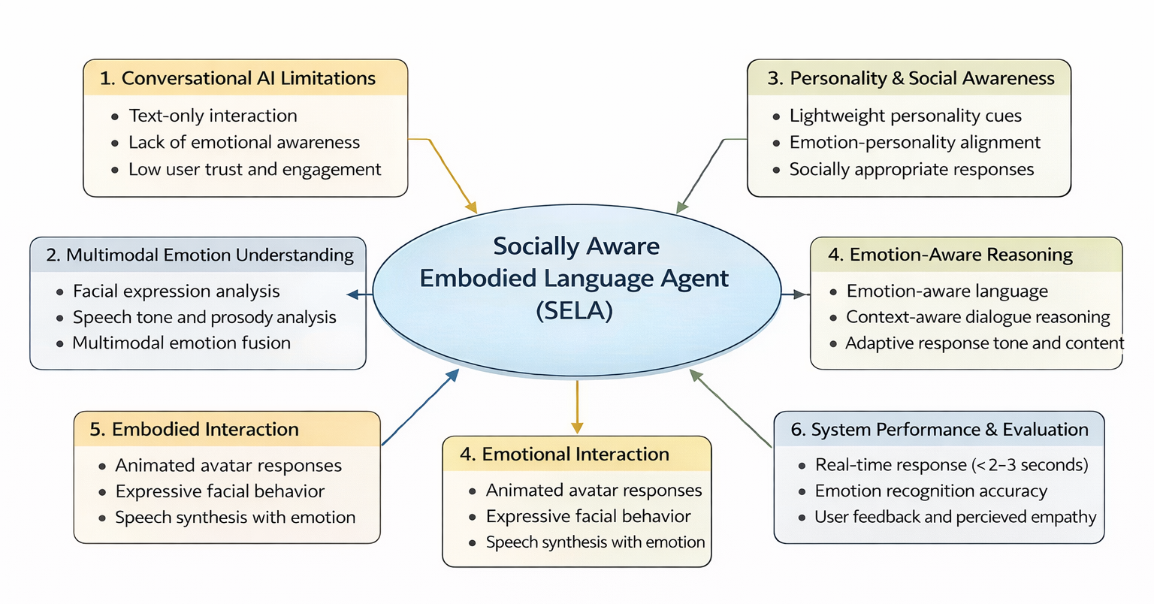

Figure 1: SELA Thematic Diagram

Table 1: Research Gap
Sources | Contribution | Limitations and Identified Gap | How SELA Addresses It
(Soujanya Poria, 2017) | Reviewed affective computing from unimodal to multimodal systems. | Most systems rely on a single input (text or voice) and lack integrated affect understanding. | SELA fuses audio + visual emotion sensing with adaptive reasoning.
(Hailun Lian, 2023) | Surveyed deep learning-based multimodal emotion recognition (MER). | MER models achieve accuracy but lack real-time adaptation and cross-cultural robustness. | SELA applies lightweight real-time affect inference models for live interaction.
(Naveed Ahmed, 2023). | Systematic review of MER architectures and datasets. | Existing multimodal systems are computationally heavy and unsuitable for real-time or edge use. | SELA designs low-latency, resource-efficient architecture that can be deployed on standard hardware.
(Shubham, et al., 2022) | Discussed ECA architectures for commercial applications. | ECAs use scripted logic, failing to synchronize understanding, reasoning, and emotional expression. | SELA integrates all modules—emotion, reasoning, embodiment—into a cohesive adaptive pipeline.
(Sinan Sonlu, 2024) | Analyzed embodiment and personality expression in LLM-based educational agents. | Personality expression improves engagement but lacks integration with emotion awareness. | SELA links personality cues to emotion inference to enable socially aware responses.
(Che-Jui Chang, 2023) | Studied multimodal emotion conditioning and affect consistency in ECAs. | Emotional conditioning exists, but agents still lack real-time adaptation and personalization. | SELA continuously affects sensing and LLM-driven response adaptation.
(Andrei Nosov, 2024) | Proposed a deep-learning-based multimodal sentiment analysis framework for ECAs. | Focused on emotion recognition only, without reasoning or embodied response generation. | SELA extends to emotion, reasoning, and embodiment, bridging perception and expression.
(Simon Christophe Jolibois, 2025) | Evaluated emotional ECAs and the effect of response delay on user impression. | Found that latency harms user experience; most systems fail to manage delay effectively. | SELA emphasizes <2.5s latency through optimized pipelines.
(Schuller, 2018) | Surveyed two decades of speech emotion recognition. | SER models are accurate but not integrated with visual and reasoning systems. | SELA fuses voice and vision for richer emotion recognition.
(Tadas Baltrušaitis, 2019) | Defined taxonomy for multimodal machine learning. | Theoretical survey — lacks practical fusion in conversational contexts. | SELA applies fusion and alignment principles to dialogue modeling.
(Zhang, 2025) | Investigated user navigation in emotion-aware conversational agents. | Focused on emotional expression but not multimodal understanding. | SELA combines affect sensing + embodied interaction for adaptive empathy.

This table presents a comparative analysis of related work. It compares key contributions and limitations of existing approaches. Through this comparison, the research gap is identified. This gap motivates the proposed SELA system.

Chapter 05 Method of Approach

This chapter describes the methodology adopted to complete the project. It outlines the research approach, data sources and collection plan, tools and technologies, evaluation strategy, and project management methodology. The selected approach ensures that the project objectives are achieved in a structured, ethical, and measurable manner.
The project adopts a prototype-based experimental research approach. The main objective is to design, implement, and evaluate a functional prototype of a Socially Aware Embodied Language Agent. The prototype is used to assess the feasibility of integrating multimodal emotion sensing, personality inference, language reasoning, and embodied interaction within a single conversational system. This approach is suitable because the project focuses on concept validation and performance evaluation rather than full-scale production deployment.

Data Sources and Data Collection Plan

The system uses multimodal data, including facial expressions, speech signals, and conversational text. Data are collected from publicly available datasets (e.g:- GitHub, Kaggle, etc) and from controlled user interactions following ethical guidelines.

- Facial data: Public emotion recognition datasets with labeled facial expressions
- Audio data: Speech emotion datasets with annotated emotional states
- Text data: Conversational datasets and synthetic prompts for dialogue evaluation
- Additional data: Controlled user interaction data for testing purposes

Where user interaction data is collected, informed consent is obtained. All data is anonymized and securely stored. No personally identifiable information is retained beyond experimental needs.

Algorithms, Tools, and Technologies

The project employs established AI and software development tools to ensure reliability and reproducibility.

- Programming language:- Python
- Deep learning frameworks:- PyTorch, TensorFlow
- Computer vision:- OpenCV, MediaPipe
- Speech processing:- Librosa, SpeechBrain
- Natural language processing: Transformer-based Large Language Models via API integration
- Avatar and embodiment:- Unity or web-based 2D/3D avatar frameworks
- Version control:- Git and GitHub

Pre-trained models are fine-tuned where necessary to reduce training time and computational cost.

Evaluation Metrics and Validation Strategy

The system is evaluated using both quantitative and qualitative methods.

- Emotion recognition accuracy for facial and speech inputs
- End-to-end response latency to assess real-time performance
- Consistency between inferred affective states and generated verbal and visual responses
- User interaction quality measured through structured user feedback

Validation is conducted using controlled testing scenarios and comparative analysis with a baseline text-only conversational agent.

Project Management Methodology

An Agile project management methodology is adopted given the project's experimental and iterative nature. Development is divided into short sprints, enabling incremental implementation and evaluation of system components.

- Iterative development cycles.
- Sprint-based deliverables (modules, evaluations, documentation).
- Regular testing and review sessions.
- Continuous refinement based on evaluation results and user feedback.

This approach supports flexibility, early validation, and effective risk management throughout SELA system development.

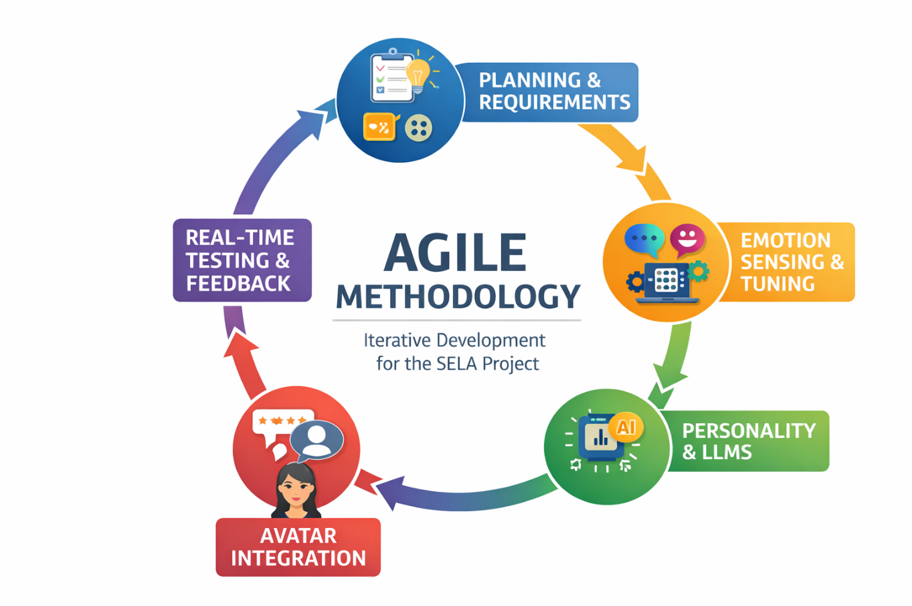
Figure 2 : Project Management Methodology Diagram

An Agile methodology was adopted for the iterative development and evaluation of the SELA system.

Chapter 06 Conceptual Diagram

Below Figure 3 : Conceptual architecture of the Socially Aware Embodied Language Agent (SELA) presents the conceptual architecture of the proposed Socially Aware Embodied Language Agent (SELA). The diagram illustrates the end-to-end flow of multimodal inputs through perception, reasoning, and output layers, highlighting how emotion sensing, language reasoning, and embodied response generation are integrated to enable empathetic conversational interaction.

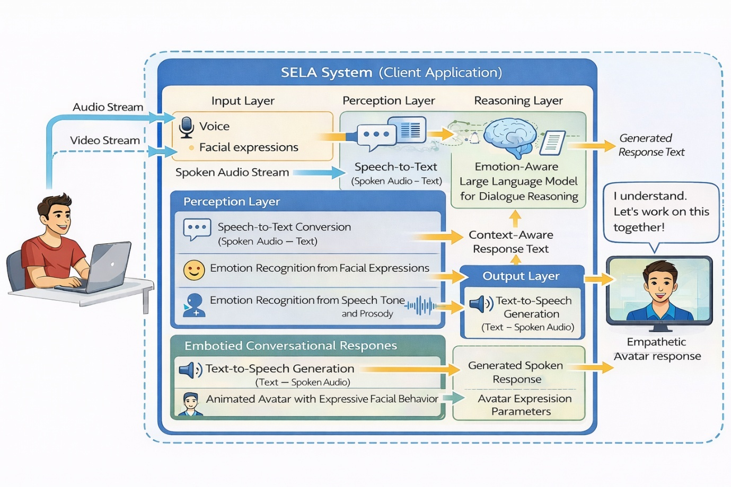

Figure 3 : Conceptual architecture of the Socially Aware Embodied Language Agent (SELA)

Chapter 07 Initial Project Plan

The timeline outlines the sequence of activities from the start of analysis to project completion.

Figure 5: Gannt Chart for SELA project timeline over 7 months from analysis to submission

Chapter 08 Risk Analysis

This chapter identifies potential risks that may affect the project's successful completion and outlines mitigation strategies for each risk.

Risk | Likelihood | Impact | Mitigation Strategy
Limited dataset quality | Medium | High | Use multiple datasets and data augmentation techniques
Higher response time. system latency | Medium | High | Optimize models and use lightweight architectures
Integration complexity | Medium | Medium | Modular development and incremental integration
Privacy and ethical concerns | Low | High | Use anonymized data and obtain informed consent
Time constraints | Medium | Medium | Agile planning with buffer time for critical tasks

Regular risk reviews will be conducted throughout the project lifecycle to ensure timely mitigation and minimal disruption.

References

Andrei Nosov, S. S. A. L., 2024. Embodied Conversational Agents: Deep Learning Based Multimodal Sentiment Analysis.

Anon., 2023. Artificial Intelligence and Human Development: Opportunities and Challenges for Inclusive and Ethical AI, New York: United Nations Development Programme (UNDP).

Che-Jui Chang, S. S. S. S. Z. R. J. M. U. M. K., 2023. The Importance of Multimodal Emotion Conditioning and Affect Consistency for Embodied Conversational Agents.

Hailun Lian, C. L. S. L. Y. Z. C. T. Y. Z., 2023. A Survey of Deep Learning-Based Multimodal Emotion Recognition: Speech, Text, and Face.

Kumar Shubham, L. N. N. V. D. B. J. R. T., 2022. Multimodal Embodied Conversational Agents: A discussion of architectures, frameworks and modules for commercial applications.

Naveed Ahmed, Z. A. A. G., 2023. A systematic survey on multimodal emotion recognition using learning algorithms.

Schuller, B. W., 2018. Speech emotion recognition: two decades in a nutshell, benchmarks, and ongoing trends.

Shubham, K., Venkatesan, L. N. N., Jayagopi, D. B. & Tumuluri, R., 2022. Multimodal Embodied Conversational Agents: A discussion of architectures, frameworks and modules for commercial applications.

Sidney K. D'mello, J. K., 2015. A Review and Meta-Analysis of Multimodal Affect Detection Systems.

Simon Christophe Jolibois, A. I. T. N., 2025. The Development of an Emotional Embodied Conversational Agent and the Evaluation of the Effect of Response Delay on User Impression.

Sinan Sonlu, B. B. F. D. U. G., 2024. The Effects of Embodiment and Personality Expression on Learning in LLM-based Educational Agents.

Soujanya Poria, E. C. R. B. A. H., 2017. A review of affective computing: From unimodal analysis to multimodal fusion.

Tadas Baltrušaitis, C. A. L.-P. M., 2019. Multimodal Machine Learning: A Survey and Taxonomy..

Tom B. Brown, B. M. N. R. M. S. J. K. P. D. A. N. P. S. G. S. A. A. S. A. A. H.-V. G. K. T. H. R. C. A. R. D., 2020. Language Models are Few-Shot Learners.

Zhang, Y. M. Y. ,. D. F. P. S. F. M. K. D., 2025. Navigating Users in Emotion-Aware Conversational Agents: Exploring Strategies for Enhanced Interaction.

